Timeline | Task | Resources | Complete
Pre-Construction  (12 Weeks Out) | Review the Pre-opening Marketing Timeline | - CDS SOP Manual
Pre-Construction  (12 Weeks Out) | Set a Meeting with the Walmart Manger- This meeting is combined with the Pre Construction Meeting. Topics include but are not limited to:  - Meet and greet/introductions.  - Any promotional materials that will be installed during the pre- grand opening and for the weeks surrounding it, show the “Plan O Gram” & all the items you are going to display. Be sure to get approval and buy in from the Walmart Manager  - Any discounts or offers that will be introduced to the Walmart staff. Show the discount poster that goes in the breakroom (example- discounts have been 10-20 % off.)  - Ask to be part of the Walmart daily team rallies for the 1st week or 2 after opening.  - Ask if announcements can be made on the loudspeaker for the grand opening directing people to visit the new MIAMI GRILL…?  - Discuss important dates like construction completion and “Go Live.”  - Can they do a “AD” on the back TV Wall in the Electronics Department?  Order the Pre-Opening Kit (will arrive by 10 weeks out) | - CDS SOP Manual  - Walmart Tenant Handbook  - Plan-O-Gram  - Tenant creates an agenda using the topics provided and adds any additional items to discuss  - www.miamigrill.twintowersmarketing.com
6 Weeks Out  Order the Print Media Packages | 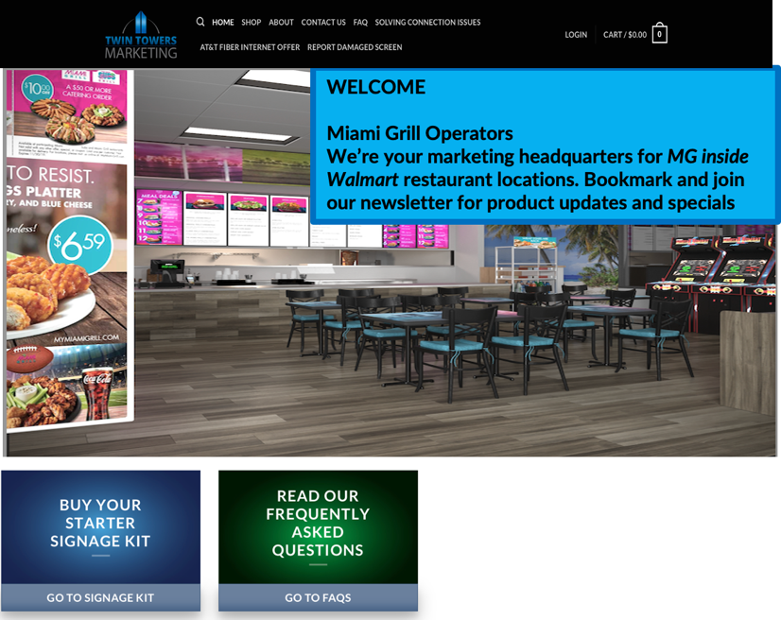 | - www.miamigrill.twintowersmarketing.com
5 Weeks Out  (as Delivered) | Check in Digital and Print Media Packages- All Damaged or missing items must be reported within 24 to 48 hours with NO EXCEPTIONS to the FMX System. | http://tttsm.gofmx.com  - CDS SOP Manual  - FMX System
Associate Appreciation Day  Night Before or Early | 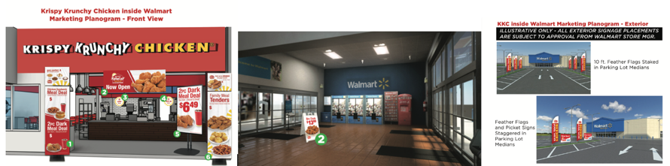  EXAMPLE ONLY- Each Brand has a specific “Plan-O-Gram” for that brand located on the Twin Towers Marketing Website | - CDS SOP Manual  - Plan-O-Gram  - www.miamigrill.twintowersmarketing.com
Opening Day   | - Ribbon Cutting  - Sample  - Coupon Give Away  - Ask Guests for Feedback on Food & Service Etc. | - Ribbon & Scissors  - Food Products  - Print Media Package
90/120 Day Refresh | - Change out Value Message on the Promoter Board- Go to the tttsm.gofmx.com website to request these changes.  - Change out Banner Stand Poster (Use Price Point Marketing.) Go to www.miamigrill.twintowersmarketing.com to order these refresh materials.  - Refresh the Walmart Crew Poster. Go to www.miamigrill.twintowersmarketing.com to order these refresh material | - CDS SOP Manual  - FMX System- http://tttsm.gofmx.com  - Refresh Materials- www.miamigrill.twintowersmarketing.com

